Beauty Parlor Site:
The web template is whole about a beauty. Beauty Parlor providing an environment for gathering all details related to beauty world and also learn something new from college. So, design to maintaining all level with using a advance designing tools.
The steps for design Template Structure:
Step 1: First of all design the template using Photoshop just like below snapshot
Step 2: Maintaining all Layers of Design in the Photoshop with individual image and color combination.
Step 3: Design Navigation structure using vertical menu bar applying CSS structure. The menu has different categories:
Vertical Menu:
- Home
- Services
- Bridal
- Courses
- Fix an appointment
- Contact Us
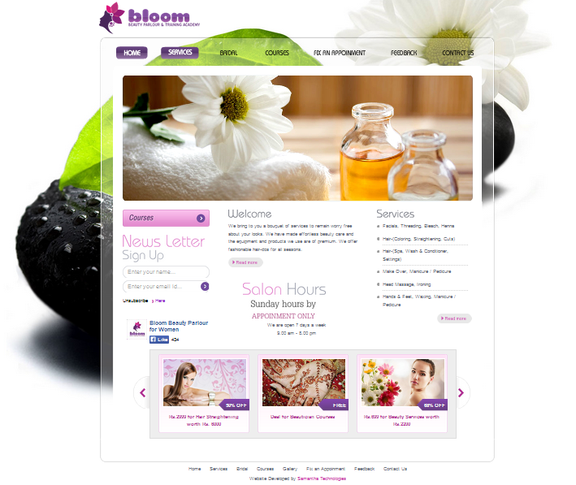

Step 4: Create at least different individual page regarding every menu items.
Step 5: All Division are maintaining by using floating attribute with creation boxes.
Step 6: Use transparency effect with Alpha Setting for each image part.
Step 7: Add at least one flash file within suitable title and logo.
Step 8: Add Background sound and give the choice for On/Off Sound.

